**SQL ASSIGNMENT**

1. **CREATE A TABLE WITH FOUR COLUMNS MAKING THAT THEY HAVE NULL CONSTRAINTS.**

CREATE DATABASE SQL1;

USE SQL1;

CREATE TABLE Employees (Emp_ID INT, Emp_Name VARCHAR(15), Age INT, Salary INT);

SELECT * FROM Employees;

DESCRIBE Employees;

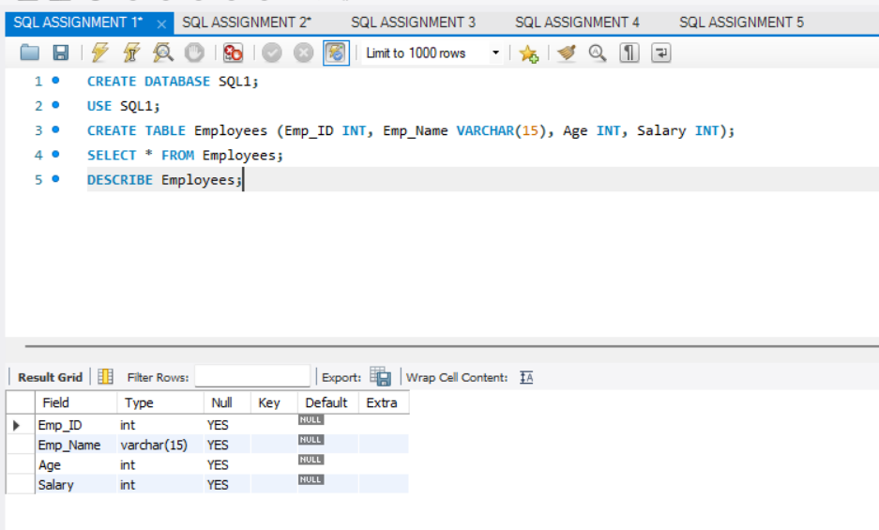

1. **CREATE A SALES TABLE HAVING COLUMNS ID, PRODUCT NAME, PRICE PER UNIT AND QUANTITY AND THEN CREATE A VIEW WHICH WILL SHOW THE TOTAL COST PER EACH PRODUCT AND PRODUCT NAME.**

CREATE DATABASE SQL2;

USE SQL2;

CREATE TABLE Products (ID INT NOT NULL, Product_Name VARCHAR(15) NOT NULL, Price_Per_Unit INT NOT NULL, Quantity INT NOT NULL);

INSERT INTO Products VALUES(51, "Kajal", 75, 5), (52, "Lip Balm", 120, 10), (53, "Face Powder", 100, 6), (54, "Serum", 140, 12), (55, "Primer", 200, 15);

SELECT * FROM Products;

CREATE VIEW Total_Cost AS SELECT Product_Name, Price_Per_Unit * Quantity FROM Products;

SELECT * FROM Total_Cost;

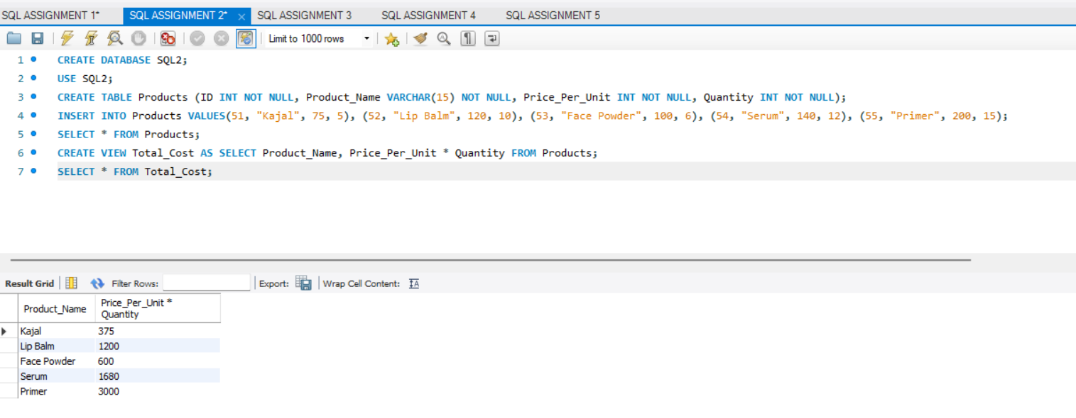

1. **WRITE A QUERY TO RETURN A SUM OF ALL THE AGES IN THE TABLE.**

CREATE DATABASE SQL3;

USE SQL3;

CREATE TABLE People (ID INT NOT NULL, Name VARCHAR(10) NOT NULL, AGE INT NOT NULL);

INSERT INTO People VALUES(1, 'Bob', 21), (2, 'Sam', 19), (3, 'Jill', 18), (4, 'Jim', 21), (5, 'Sally', 19), (6, 'Jess', 20), (7, 'Will', 21);

SELECT * FROM People;

SELECT SUM(Age) FROM People;

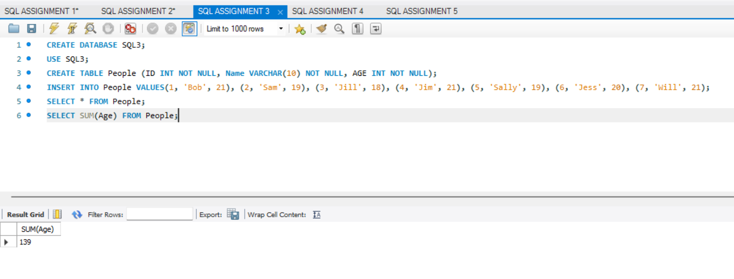

1. **WRITE A QUERY THAT’LL GROUP ALL THE PEOPLE BY THEIR AGE ALONG WITH A COUNT OF THE PEOPLE WHO ARE IN THE SAME AGE.**

CREATE DATABASE SQL4;

USE SQL4;

CREATE TABLE People (ID INT NOT NULL, Name VARCHAR(10) NOT NULL, AGE INT NOT NULL);

INSERT INTO People VALUES(1, 'Bob', 21), (2, 'Sam', 19), (3, 'Jill', 18), (4, 'Jim', 21), (5, 'Sally', 19), (6, 'Jess', 20), (7, 'Will', 21);

SELECT * FROM People;

SELECT *, COUNT(Name) FROM People GROUP BY Age;

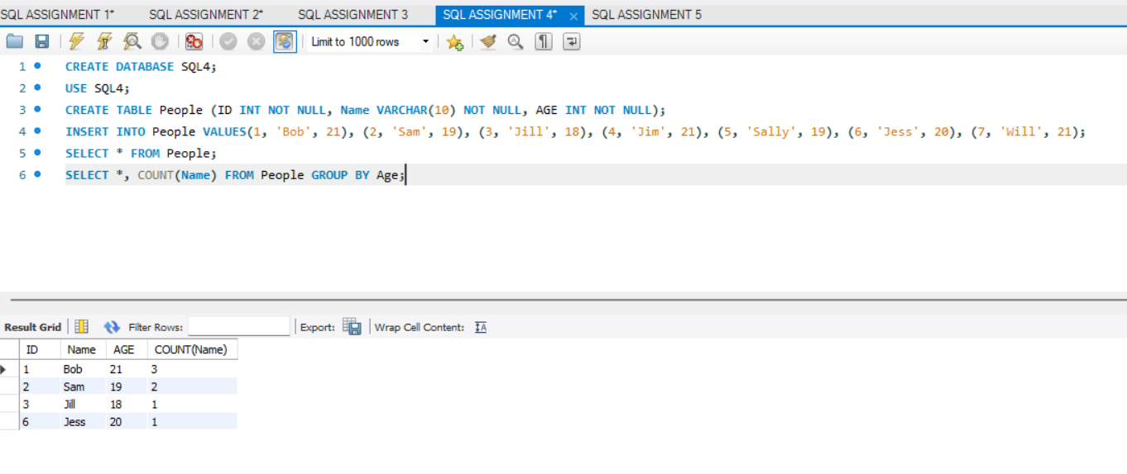

1. **WRITE A QUERY THAT’LL RETURN JUST THE DIVISION IDS FOR ALL THE DIVISIONS THAT HAD POSITIVE REVENUES IN 2021.**

CREATE DATABASE SQL5;

USE SQL5;

CREATE TABLE Company (Division_ID INT NOT NULL, Year INT NOT NULL, Revenue INT NOT NULL);

INSERT INTO Company VALUES(1, 2018, 60), (1, 2021, 40), (1, 2020, 70), (2, 2021, -10), (3, 2018, 20), (3, 2016, 40), (4, 2021, 50);

SELECT * FROM Company;

SELECT Division_ID FROM Company WHERE Year = 2021 AND Revenue IN (40, 50);

